Littles
Level 1 Lesson 3
Foreign Missions-Missions

Long Haul

(Hank works away from home)

Target: The children will learn that God commands us to spread the gospel to others. They will learn what a missionary is, what they do and where some are today.

Text: Acts 9:19-25, Acts 16:14-32

Preface: The last thing that Jesus did before ascending into heaven was to give a commandment.

Mark 28:19 “Go ye therefore, and teach all nations, baptizing them in the name of the Father, and of the Son, and of the Holy Ghost.”
Mark 16:15 “Go ye into all the world and preach the gospel to every creature.”
Luke 24:47 “And that repentance and remission of sins should be preached in his name among all nations, beginning at Jerusalem.”

God felt so strongly about spreading the gospel that it was the last thing he mentioned to his disciples. Missionaries and evangelists today are fulfilling this commandment. Not only do you get a chance to teach the children the importance of what a missionary does, but you also get to teach them that they too can spread the gospel of Jesus Christ right here, where they live. One thing I tried to bring out in this lesson’s story about Paul is that he continued to spread the gospel despite the beatings, imprisonment, and other adversities he encountered.

Activities and Materials:
Story | Story | Letters from Paul | Memory Verse | Snack | Offering | Take home craft
Color and cut out Paul. | Color and cut out Lydia’s family and the jailer’s family. | Bible Map | World maps.  Liquid glue, such as Elmer’s or any spreadable glue. | Tablecloth or covering for table. | World Map with holes cut in a few areas. | Paul’s journey map.  Coloring supplies  Glue
Baby doll in a basket with rope attached or the cut out of Paul in a basket with piece of yarn or string attached.  Wall-can be made of cardboard and painted or colored to look like bricks. | Baptizing Lydia & Jailer: A wading pool filled with blue balloons or crunched up blue construction paper. Or you can use a picture of a river or lake. Or simply lay blue construction paper on the floor that looks like a river. | Cut out the envelopes to attach to the map. | Cut out paper dolls.  Glitter, candy sprinkles or confetti.  Paint smocks or Large T-shirts. | Anything spreadable, Peanut butter and jelly on bread, or frosting on graham crackers, cupcakes or cookies, or spreadable cheese on crackers. | Ziploc bags.  Tape.  Coins. | Pre-cut out of Paul with suitcase and precut out pieces of paper with memory verse written on them.
Boat to travel to Macedonia. See the examples attached at the end of lesson. | Black crepe paper. Tape. | Tape. |  |  |  | Coloring page of Paul on boat.  Coloring supplies

Welcome: As the children enter have them punch in on their timecard or move their truck on the mileage chart for attendance. Welcome guests and acknowledge birthdays.
Frank walks by with a suitcase in his hand. He is mumbling about things he can’t forget to pack and picking up items and putting them in his suitcase such as a shirt and socks.
Teacher: Hi Frank. What are you doing?

Frank: Packing. Continues to mumble and pack.

Teacher: Packing for what; where are you going?

Frank: I must drive one of our trucks to (name a place that is far from your city). So I must pack some clothes and things I will need, because it’s really far from here.

Teacher: Oh I see, you will be working away from home. Well, we will miss you, Frank. Right kids? Let the children respond.

Frank: I’ll miss you guys too. It’s hard to be away from home sometimes. Well, I better get going. I have a long way to drive.

Teacher: Oh Frank wait. Pick up Frank’s Bible and take it to him. Don’t forget your Bible.

Frank: Thank you. I don’t want to forget that. Bye everyone.
Frank exits.

Teacher: It’s hard to be away from home. You don’t have your own bed to sleep in or all your toys to play with. You would miss your friends and family if you were away for a long time, right? Allow children to respond. Did you know that there are some people who leave their homes and go really far away to teach other people about Jesus? They are called missionaries, and they go all over the world.

Offering: Cut holes in a few areas (large enough to fit coins through) around the map. Tape either a Ziploc bag or small paper cup to the bottom of the map, under the hole. Here we have a picture of the entire world. Show the children the offering map. It’s called a map. It is just like the globe, but this map is flat. Missionaries need money to help buy Bibles and supplies to teach people about Jesus. Today we are going to give our offering to help some missionaries do that. We are going to pick one of the places on this map and put our offering in the places where some missionaries are. Help the children find a hole to put their offering into. Bring extra coins for children who don’t have offering. Even a penny each would be fine.

Prayer: Hold up a globe (if you do not have a globe use a world map). Who knows what this is? Allow children to respond. It’s called a globe (or a map if that’s what you are using). It shows us all the places in the world. Find the area that you live in. Point to it on the globe. This is where we live. We are going to pray for missionaries who live other places. We are going to ask God to help them spread the gospel (which is the Word of God, the Bible) to people who live there. Close your eyes and point to a place on the globe. I picked (name the place you pointed to). Let’s pray for that place. Let each child (or for a large group, as many as time allows) point to a place and everyone pray for that place.

Transition: God created the whole world, and He loves everyone in the whole world. That’s why He wants us to tell everyone about Jesus. So everyone can know about Him and know how to make it to heaven. Let’s sing a song.

Theme Song: He’s Got the Whole World in His Hands
Pass around a globe while singing. | Verse 1: | He’s got the whole world  in His hands.  He’s got the whole world in His hands.  He’s got the whole world in His hands.  He’s got the whole world in His hands.
Cradle arms like you are holding a baby. | Verse 2: | He’s got the little bitty baby, in His hands.  He’s got the little bitty baby, in His hands.  He’s got the little bitty baby, in His hands.  He’s got the whole world in His hands.
Point to each other. | Verse 3: | He’s got you and me, brother, in His hands.  He’s got you and me, sister, in His hands.  He’s got you and me, brother, in His hands.  He’s got the whole world in His hands.

Memory Verse: God tells us in the Bible that He wants us to tell all the world about Him, and tell people how they can go to heaven. It says in Mark 16:15 “Go ye into all the world and preach the gospel…” Have the children repeat it a few times with you.
Have the children put on their paint smocks. If you do not have smocks, you can use large old T-shirts that will cover the children’s clothing. Give each child a flat map of the world with the paper dolls glued on (Glue the paper dolls to the map before class). Spread glue (gospel) all over the map, and the paper dolls (people). Have the children sprinkle glitter, candy sprinkles or confetti over the entire map and people. The sprinkles are the word of God being spread throughout the world. Explain what the sprinkles represent and to make sure they spread it everywhere. Have the children wash their hands and get ready for snack time.

Snack: When you spread something, you take something from one place and move it all around to other places. Let’s practice spreading things around with our snack today. Pass out plastic knives and snack items. Anything that is spreadable will work. Some suggestions are peanut butter and jelly sandwiches or frosting on graham crackers, cupcakes or cookies or spreadable cheese on crackers. Please be aware of any food allergies the children may have.

Story: You will need two areas that are across the room from each other, so the children can travel to the story areas. The first area is Damascus. Damascus will have a wall that you are going to lower Paul down in a basket. Paul can be a baby doll in a basket attached to a rope that you lower down over the wall. Or you can use the cut-out Paul and basket and attach it to a string. Then you will want to walk a little to take a small boat to travel to the second area, which is Macedonia. To make a boat the children can “sail” in you can set chairs in rows of two or three on blue construction paper to be the water. Then put brown or white construction paper around the chairs for the sides of the boat. Make sure there is a way for the children to get in the boat. Another option is to find a large cardboard box to make a boat. One other idea if you have a small class is to make individual boats out of laundry baskets. Paul will have a friend traveling with him, Silas. Here you will visit Lydia and her family. They will all be baptized in Jesus name, so you will need a wading pool filled with blue balloons or crumpled up blue construction paper. Another option is to use a picture of a river or water and a picture of Lydia and her family. After that Paul and Silas will be taken to prison. You will need a jail. Strips of black construction paper can be hung from the ceiling to the floor to simulate jail bars. The same baptism area or picture can be used for the jailer and his family.
I’m going to tell you a story about a man named Paul who traveled to a lot of different places to tell people about Jesus. This story is in the Bible in the book of Acts. Open your Bible so the children know you are telling the story from the Bible. Paul was a missionary. (Show cut out of Paul). A missionary is someone who goes to different places around the world (show the globe or map) to tell people about Jesus and the Bible. I am going to tell you about some

things that happened to Paul while he was traveling around. Back in Bible times they didn’t have cars and planes to take them to faraway places like we have, so how do you think Paul got from one place to another? Let the children respond. He walked a lot and sometimes he had to ride in a boat. Today, we will travel like Paul, so let’s walk to the first place we are going to visit and see where Paul went. Have the children follow you to your Damascus area. Here we are in a place called Damascus. Paul preached about Jesus for many days here. He was spreading the gospel just like God tells us to do. While he was here some people got angry and wanted to kill Paul. They waited for him day and night at the gates of the city so they could take him and kill him. But Paul’s friends, the disciples, heard that they were going to try to kill Paul. So they waited until it was nighttime, and they put Paul in a basket, and they lowered him down the wall. Let the children help you lower Paul down the wall. Do you think Paul gave up telling people about Jesus because those people wanted to kill him? Let the children respond. No, Paul didn’t give up. He kept moving on to the next place to tell more people about Jesus. Let’s visit another place Paul went. Start walking towards the boat. Sometimes the places Paul went were across the ocean, so he had to travel in a boat. We are going to travel in our boat to Macedonia. Help all the children into your boat. You could have paper oars and let the children row, or you could have them act out being on a boat, rocking side to side. We made it! Help the children out of the boat. When Paul traveled to Macedonia, he took a friend named Silas with him. They stopped and began talking to a woman named Lydia. Lydia listened to everything Paul had to say, and she got baptized, and her family got baptized too. Place Lydia and her family on the picture of the water or river. Then after Paul and Silas stayed with Lydia and her family for a while, they left to go pray, and do you know what happened? A woman started following them who had an evil spirit in her, and she cried “These men are the servants of the most high God, which shew unto us the way of salvation.” Make your voice sound like you are teasing or whiney when you speak the woman’s part. She did this for many days until Paul was so upset, he turned around and said, “I command thee in the name of Jesus Christ to come out of her,” and the evil spirit came out of that woman. But some people were not happy that Paul did that, and they had Paul and Silas thrown into jail. Walk over to the jail. Begin looking all around the jail like you are puzzled. Wait a minute. I don’t see Paul and Silas in the jail, do you? Let the children respond. The Bible says that they beat Paul and Silas up, then threw them in jail. They put their hands and feet in stocks. And they put a man, a jail keeper, there to make sure they didn’t escape. You may need to explain what stocks are. Or you could say they chained their hands and feet. Toddlers may understand that better. How do you think Paul and Silas felt? Let children respond, they may say sad or scared. Well, at midnight Paul and Silas started praying and they sang praises to God and while they did this there was a rumbling. Act like you are shaking from an earthquake. It was an earthquake and their chains fell off their hands and feet, and the door to the jail opened. Paul and Silas were free! But the jail keeper was scared that he would be in trouble because
the jail was open, and Paul and Silas could just walk out.

But Paul spoke to the jail keeper and said don’t worry we are still here. The jail keeper was amazed, and he brought Paul and Silas out of the jail and took them to his house. The jail keeper asked them “what must I do to be saved.” Paul and Silas told the jail keeper and everyone in his house what they must do to be saved. And the jail keeper and everyone in his house were baptized that very night. Guide the children back to the seating area where you began. A lot of bad stuff happened to Paul when he was traveling around telling people about Jesus. Do you think Paul said, I’m not going around talking about Jesus anymore because people have tried to kill me, and some people made fun of me, and I was even thrown in jail? No, Paul went to many other places and continued telling people about Jesus.

Letters from Paul: Many books of the Bible were letters that Paul wrote to places where he had visited. Show Paul’s journey map. For example, Paul visited Rome and he wrote a letter to the people there. That letter is in the Bible, and is called Romans. Have one of the children help you attach the Romans letter to the map. Paul wrote two letters to the church in Corinth. In the Bible it is called 1st and 2nd Corinthians. Let a child help you attach the Corinthians letters. He wrote a letter to the church at Galatia. It is called Galatians. Have a child help you attach Galatians. Another letter Paul wrote to a place he visited was Ephesus. In the Bible the letter is called Ephesians. Have a child help you attach Ephesians. Paul visited Philippi and wrote a letter to them that is called Philippians. Attach Philippians letter. Paul also visited Colossae. That letter is called Colossians. Attach Colossians letter. He wrote two letters to the Thessalonians. Attach the Thessalonians’ letters. You may add Hebrews here, even though it is said the author of Hebrews is uncertain, Paul is commonly attributed to writing Hebrews. He wrote a letter to the Hebrews. Attach the Hebrew letter. Paul also wrote letters to his friends who were also missionaries. He wrote two to Timothy. Attach two letters to Timothy. Paul wrote a letter to his friend Titus. Attach a letter to Titus.

Take home story craft: Pass out Paul’s journey map. Let the children color the map, then glue on Paul with his suitcase and the memory verse. As an alternative you can have the children glue on pre-cut out pictures of Paul in the basket, Lydia’s family and the jailer’s family, and Paul and Silas singing in jail. This craft will allow the children to retell the story at home. If time allows let them practice retelling the story from their paper.

Pass out or allow the children to take home the coloring page “Paul traveled to many places talking about Jesus.”

Theme Song: This Little Light of Mine
Hold up index finger. | Verse 1: | This little light of mine,  I’m gonna let it shine.  This little light of mine,  I’m gonna let it shine.  This little light of mine,  I’m gonna let it shine.  Let it shine, let it shine, let it shine.
Cup hand over the top of index finger. | Verse 2: | Hide it under a bushel, no!  I’m gonna let it shine.  Hide it under a bushel, no!  I’m gonna let it shine.  Hide it under a bushel, no!  I’m gonna let it shine.  Let it shine, let it shine, let it shine.
Shake head no.  Blow on top of index finger like you are blowing out a candle. | Verse 3: | Won’t let Satan blow it out, I’m gonna let it shine.  Won’t let Satan blow it out, I’m gonna let it shine.  Won’t let Satan blow it out, I’m gonna let it shine.  Let it shine, let it shine, let it shine.

Dismissal: Make sure students have their take home items, do a final review of the memory verse, and pray.

Down the Road: If you made a boat for this lesson then save it because it will be used again in lessons 40 and 44.

Boat ideas for classrooms

Laundry basket boat Cardboard boat
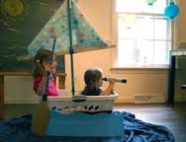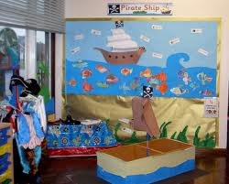
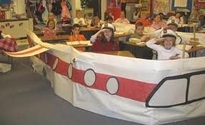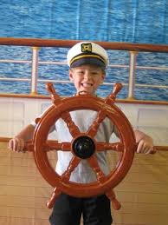
Construction paper around chairs. Boat wheel.
(Can be done on a smaller scale.)

Letters from Paul: I would color the map to make it visually appealing to a young age group. The map can be enlarged using an overhead projector. This is to show you an example of the envelopes. You can tape them flat on the map.

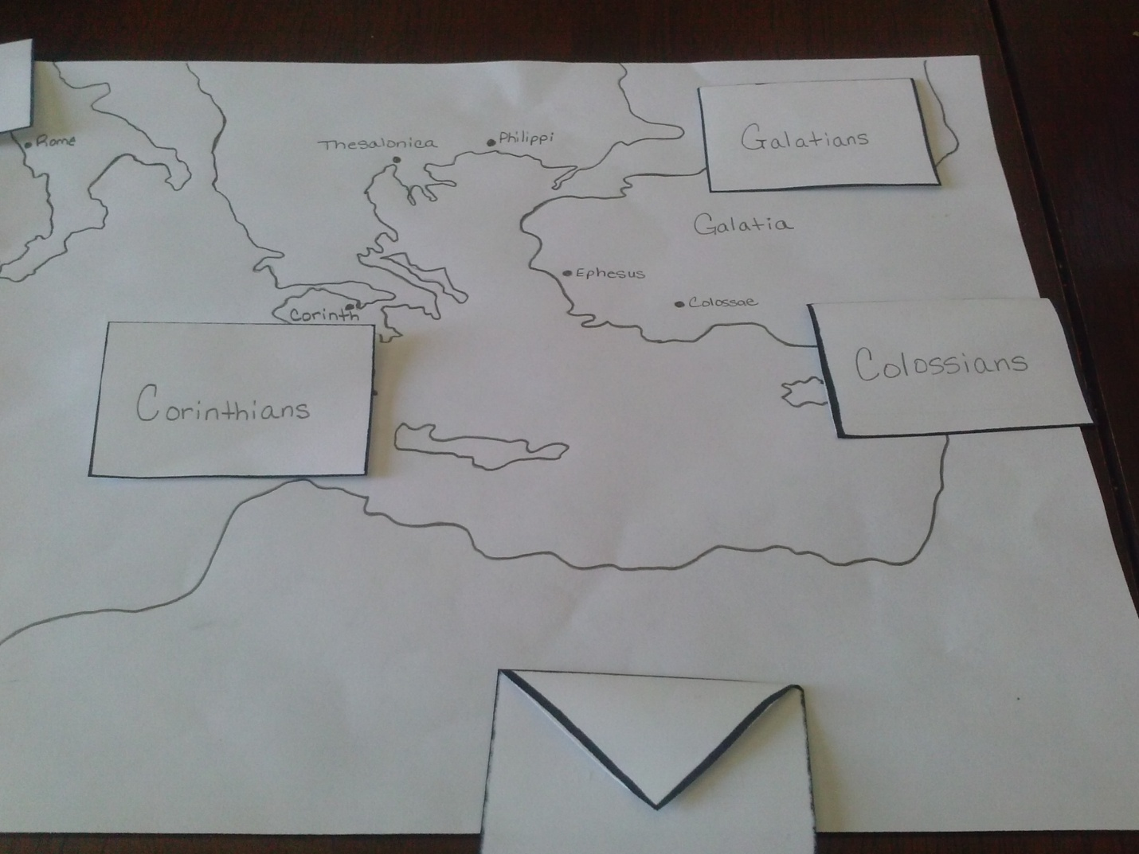

Another option for telling the story if your space does not allow for you to walk around and make the props is to make a story map. A color the “Paul’s journey” map. Glue or tape the characters at the appropriate places as you tell the story. You could also have the children make one for the take home paper and glue the memory verse to the bottom as an alternative to the take home craft: Paul spreads the gospel.

